Method of Payment
Follow these steps to set up methods of payments
- Click Accounts payable > Payment Setup > Methods of payment.
- Click New to create a line.
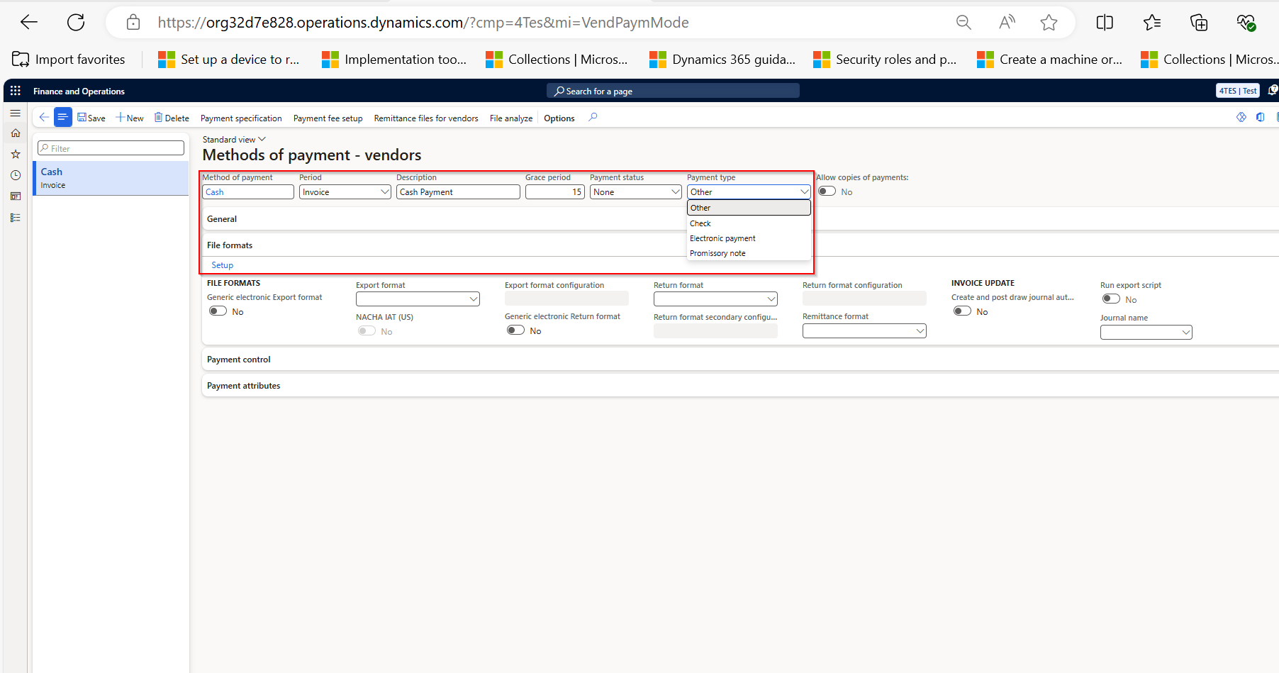
- In the Method of payment field, enter an identifier, such as Cash. (Mandatory)
- In the Period field, select the period for which invoices in automatic payment proposals are combined:
  - Invoice – One payment transfer is created for each invoice.
  - Date – All invoices for a vendor or customer that have the same due date are combined.
  - Week – All invoices for a vendor or customer that have a due date in the same week are combined.
  - Total – All invoices for a vendor or customer are combined into one payment.
- In the Description field, enter a name or short description for the method of payment.
- In the Grace period field, if applicable, enter the number of days after the specified period when the vendor or customer is eligible for a cash discount.
- In the Payment status field, select the payment status that must be fulfilled to post a payment that is assigned this method of payment. For a method that uses checks, the status is often Received or Sent.
- Click the File formats FastTab. In the Export format field, select the export format for this method of payment. (For Check Payment Only)
- Click Close to close the form and save the changes.

ADDITIONAL RESOURCES
https://www.google.com/search?q=Step+by+Step+guide+for+methods+of+payment+in+D365&oq=Step+by+Step+guide+for+methods+of+payment+in+D365&gs_lcrp=EgZjaHJvbWUyBggAEEUYOTIHCAEQIRigATIHCAIQIRigATIHCAMQIRigAdIBCTE2MDEzajBqOagCALACAQ&sourceid=chrome&ie=UTF-8#fpstate=ive&vld=cid:0ba528f4,vid:284wVImBJ3o,st:0

